Grade 7 Accelerated · Unit 3 · Lesson 6–7  Evaluating and Equivalent Expressions  Question Bank - Additional 3.06 | Name______________________  Date______________________  Period____________________

Show your work. Circle your final answer.
For questions 1 through 5, apply the laws of exponents to evaluate. Show your steps.
1. 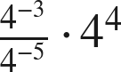

2. 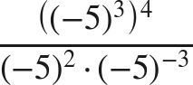

3. 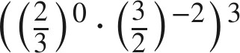

4. 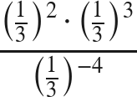

5. 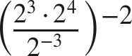

Evaluate each expression in questions 6 through 9. Show all the steps.
6. 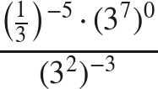

7. 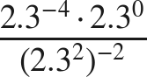

8. 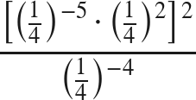

9. 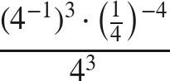

Common bases.
10. Write each expression as a single power with the base given.
a. 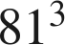 with base 3

b.  with base 2

c.  with base 4

d. 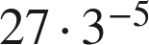 with base 3

11. Paul says 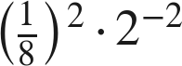 and 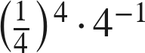 are equivalent because both can be written as .
a. Write the first expression as a single power of 2. Show your work.

b. Write the second expression as a single power of 2. Show your work.

c. Is Paul correct?

12. Which expression is equivalent to 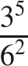 ?
○ A. 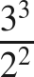
○ B. 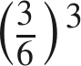
○ C. 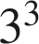
○ D. 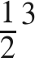

13. Find the value of that makes each statement true.
a. 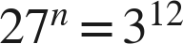

b. 